OBJECTIVES:
- To interface seven-segment to the AVR simulator.

MATERIAL:
- Atmel Studio or the assembler of your choice.
- https://lcgamboa.github.io/js/picsimlab.html?../picsimlab_examples/ (Simulator)

WEB SITES:
- www.microchip.com for Atmel Studio Software

ACTIVITY 1
- Connect a common cathode 7-segment directly to PORTD.
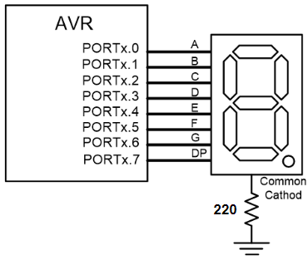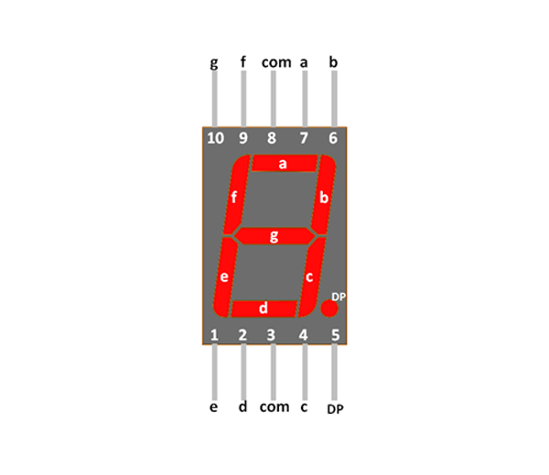
- Write the following program in the AVR Studio, build and download to the picsimlab.
LDI R20, 0xFF
OUT DDRD, R20
LDI R20, 0b00000111
OUT PORTD, R20
HERE: RJMP HERE

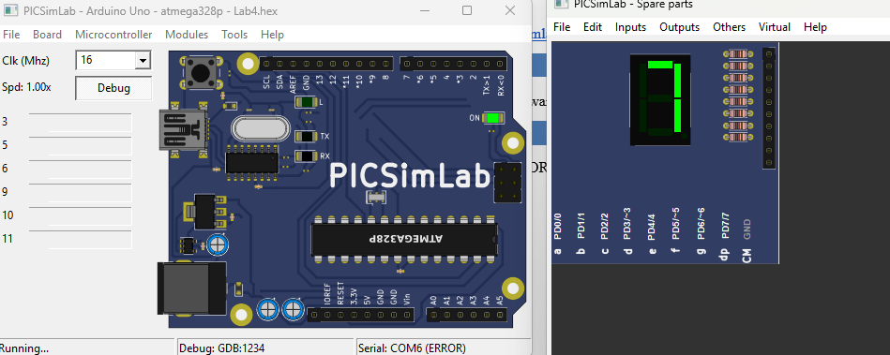

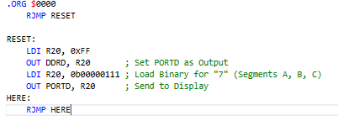

ACTIVITY 2
Modify the previous program to display 9 on the 7-segment.
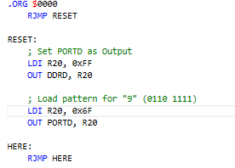
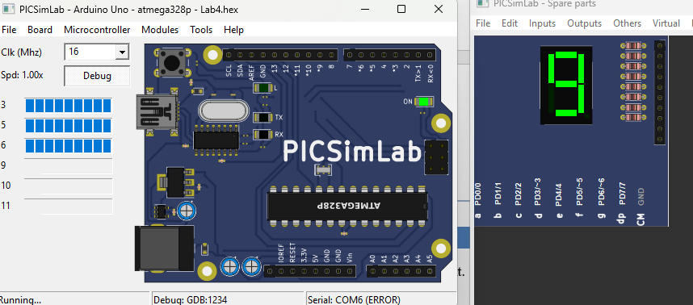

ACTIVITY 3
Use a look-up table to write a subroutine that displays the value stored in R21 on the 7-segment.
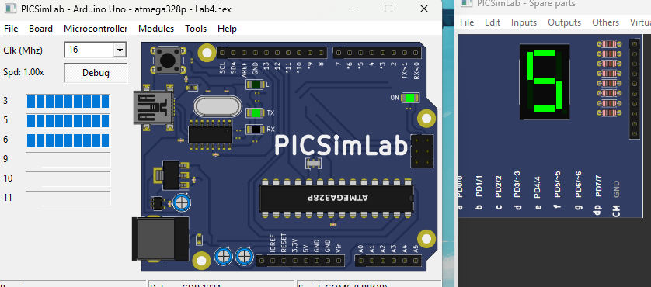
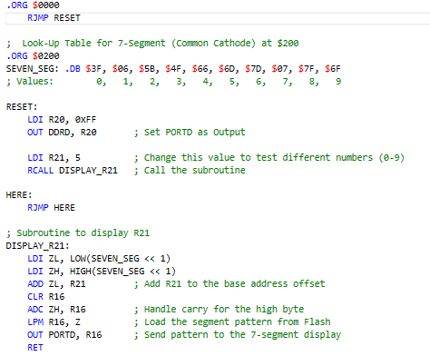

ACTIVITY 4
- Connect two 7-segments to the same port of AVR, as shown below.
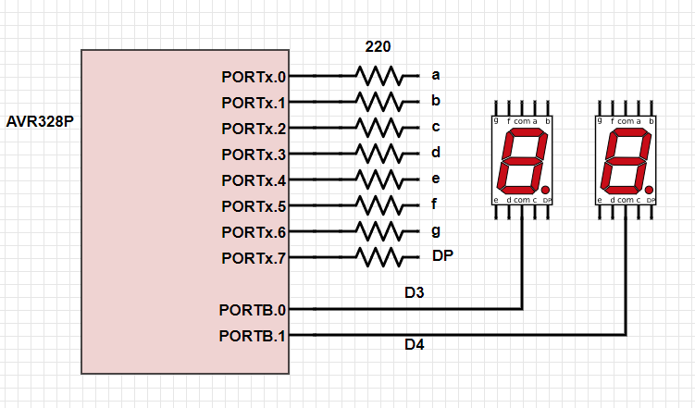
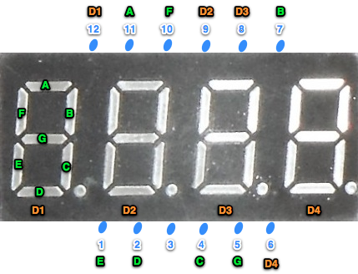
- Display 23 by scanning on those two 7-segments.
